<<WhatsCamp >>

Software Requirements Specification

Version 1.0

Revision History

|  |  |  |  |
| --- | --- | --- | --- |
| **Date** | **Version** | **Description** | **Author** |
| 21 Oktober 2017 | 1.0 | Edit Section 1  Edit Section 3.4  Edit Section 6 | Cika Desela |
| 12 November 2017 | 1.1 | Edit Section 3  Edit Section 5  Edit Section 7 | Cika Desela |
| 13 November 2017 | 1.2 | Edit Section 7.2. | Jessica Sean |

Table of Contents

1. **Introduction1**

1.1 Purpose1

1.2 Scope1

1.3 Definitions, Acronyms, Abbreviations, References1

1.4 Overview1

1. **Overall Description4**

2.1 Product Perspective5

2.2 Product Function2

2.3 User Characteristics2

2.4 Constrains3

1. **External Interface Requirement3**

3.1 Hardware Interface3

3.2 Software Interface3

3.3 Communication Interface3

**4. Software Product Features3**

**5. Other Requirements3**

5.1 Performance Requirements3

5.2 Operational Requirements4

**6. Design Constrains4**

**7. Software System Attributes: Non-Functional Requirements4**

7.1 Reliability4

7.2 Security4

7.3 Maintainability5

Software Requirements Specification

# Introduction

## 1.1 Purpose

The main purpose of WhatsCamp app is to provide an easy access for user to get information about events that is being held, has been held, and will be held in a Campus X in a period of time. The purpose of this Software Requirement Specification is to help client’s requests or needs to be explained well. So, the developer can develop the application clearly and described well. The Descriptions will be explained generally including functions and main features from WhatsCamp app, external interface requirements, WhatsCamp’ssystem constraints, and non-functional requirements

1. **Scope**

The development of WhatsCamp application will be made using Android Studio IDE version 3, with minimum API version 24. The program language will be using Java language. The main feature will be made are the application can display the events that is being held, has been held, and will be held in a period of time, view information details from an event based on user preference, search events and giving event suggestions to user, favorite events and going to events.

## Definitions, Acronyms, Abbreviations, References

**SRS:** Software Requirement Specificationsis a document that contains descriptions about the developed software systems.

**IDE:** Integrated Development Environment is a utility provider that used for developing software.

**API:** Application Programming Interface is a collection of commands, functions, and protocols and objects where programmer can use it to make software or interact with external system [1].

**Android Studio:** official IDE for Android.

# 

## 1.4 Overview

WhatsCamp application is made to fulfill Human Computer Interaction project. In this project, the main criteria is to be able to implement the concept that has been learned from HCI subject. One of part of HCI that will be implemented in WhatsCamp is, the user interaction with the application like button arrangement and placement, design activity, component’s layout, and other user interfaces. WhatsCamp will use Android Studio which use Java language and will use Java library including API for Android 24 (Nougat).

The Scope of this application is not big, due to the limited development time. The Application will be made to be able to display events that is being held, has been held, and will be held in a period of time, view the information details of an event based on user preference, search event and giving event suggestions to user based on search results, favorite events and going to event

External interface requirement will explain about the system requirements based on user interface, software interface, hardware interface and communication interface. Additional requirements such as other requirements and non-functional requirements will be explained later.

# Overall Description

## 2.1 Product (Service) Perspective

The product made by WhatsCamp will display the detail of a choosen event by user. Besides that, WhatsCamp product can give suggestion about the similar events based on user input via Search events feature. This product also giving feature to user to favorite an event so the user can view or re-access the favorited event via favorite event page. Other product is Going to Event, where the user can view some people who probably will attend to an event and user can do “attendance confirmation” so when the D-day of the event gets closer, the user will be notified about the related event.

## 2.2 Product Function

- To inform the user about events that is being held, has been held, and will be held in a Campus X in a period of time

- Giving suggestion to the user about the similar events with the user preferences.

- Re-access event that has been favorited by the user.

- View how many people or user who will probably attend to a certain event.

## 2.3 User Characteristics

WhatsCamp is designed for all people that are in Campus X, such as students, lecturers, staffs, and etc.

## 2.4 Constraint

This App only works if the device had turn on the GPS, because this application has a “Events near-by” feature that required GPS.

# External Interface Requirement

* 1. **Hardware Interface**

The minimum specification to run WhatsCamp application on Android device are:

## - RAM: 512 MB.

## - Disk space: Not Yet Defined.

## - Processor: Single core ARMV7 CPU. - Network Adapter / Wi-fi. - Resolution: at least 720p or equivalent.

## 3.2 Software Interface

## Android with API version > 24 (Android 7.0 Nougat and after).

## 3.3 Communication Interface

The Application requires internet connection to do authentication login via Facebook or Google Plus account and to do share events from WhatsCamp app to other social media.

# Software Product Features

The main features in WhatsCamp application are:

* + *View Event*, where the user can view the past event, present and upcoming events in a period of time.
  + *Search Event,* where the user can search a certain event based on his/her preference.
  + *Favorite Event,* where the user can favorite certain events.
  + *Going to Event*, where the user can do “attendance confirmation” to an event and view how many people who probably will attend the event.

# Other Requirements

1. **Performance Requirements**

WhatsCamp application must be run in a major of Android devices with its minimum specifications.

**5.2 Operational Requirements**

The device must be using Android operating system, able to use GPS sensor, and have internet connections.

# Design Constraints

Design constraints from WhatsCamp app are:

* The programming language will be using Java language.
* Fulfill the standard that have been made based on the application design manual that uses the basic principles of human computer interaction.

# Software System Attributes: Non-Functional Requirements

1. **Reliability**

WhatsCamp application is designed to be a reliable application, which means it is easy to learn and gives best experience to the user when the user uses this application. It is possible to do so because in developing the application, the developer considers the psychological aspect of the user who has different habits in using an application, so that the WhatsCamp application is designed to be be user-friendly in order to be used by a user with different habits and background.

1. **Security**

This project stored all data in database that located in PhpMyAdmin, and all user that connected in host’s network could do read and write in the database. Users could add new events, remove and edit their own events. Therefore, there need to be a security layer, so that prohibited user to access freely to database as admin. WhatsCamp uses authentication of user so that only host admin could directly access to PhpMyAdmin and do add, edit and remove entries of tables. This is proved by our experiment in Picture 1 that try to access PhpMyAdmin from other user’s devices by connecting to host’s network and accessing to host’s IP address.

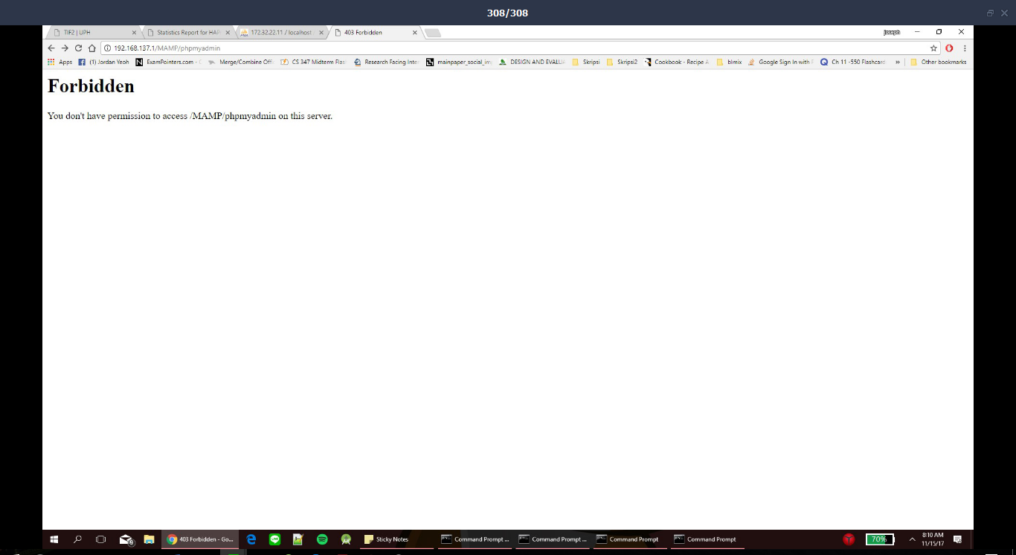

**Picture 1. User experiment to access PhpMyAdmin**

1. **Maintainability**

For WhatsCamp application maintenance, we plan to add new useful features to give more pleasing experience to the user if it possible to implement those new features in a short of time.

|  |  |
| --- | --- |
| [1] | "API," [Online]. Available: https://techterms.com/definition/api. [Accessed 21 October 2017]. |